

**RAPE DETECTION AND PREVENTION SYSTEM USING IOT AND MACHINE LEARNING**

**NJOROGE ESTHER WAMBUI: 102008**

**SUPERVISOR: JAMES GIKERA**

An information system project proposal submitted to the faculty of information technology in partial fulfilment of the requirements of the award of a degree in Information and Computer science.

Date of submission: 23 June 2020

# Declaration

I declare that this project has not been submitted to any other university for the award of Bachelor of Science informatics degree

Student Name: Njoroge Esther Wambui

Admission Number: 102008

Signature …………… Date…………………

I certify that this work is being submitted for examination with my approval.

Supervisor name: James Gikera

Signature …………… Date………………

# Abstract

*Gender based violence is a recurrent predominant issue in the society. There are actions that have been taken to suppress the situation but most of them incline to be unsuccessful.*

*Women tend to be easily targeted when they are alone or highly intoxicated. Thereafter, the victim may try to reach out to people or report the incident to the police, but the response time tends to be long and the reported case may not be treated with the seriousness it deserves due to factors like lack of evidence or unclear reports by the victim.*

*The aim of this project is to reduce response time by reaching out to a number of people at once, provide evidence of physical struggle and possibly prevent the abuse from occurring. The proposed solution is a watch like device that is incorporated into two segments IOT and Machine Learning. The IOT will include sensors to check the pulse rate, GSM and GPS modules that will facilitate communication with the selected contacts and the Machine Learning segment: creating a model that will be used to detect any signs of physical struggle and later a report will be generated with regards to the data collected. The report may be used for evidence.*

***Keywords:*** *IOT, Gender Based Violence, Machine Learning.*

# Table of Contents

Declaration ii

Abstract iii

Table of Contents iv

Table of Figures vi

Chapter 1: Introduction 7

1.1 Background 7

1.2 Problem Statement 2

1.3 Aim 3

1.3.1 Specific Objectives 3

1.3.2 Research questions 3

1.3 Justification 3

1.4 Scope 4

1.5 Limitation 4

Chapter 2: Literature Review 5

2.1 Introduction 5

2.2 Struggles experienced by victims during assault. 5

2.3 Existing Solutions for Sexual Violence 5

2.3.1 ATHENA 5

2.3.2 Watch Over Me 6

2.3.3 SMART GADGET FOR WOMEN SAFETY USING IoT 7

2.3.4 Prevention Education 8

2.3.5 SHE‐ Society Harnessing Equipment (IoT) 8

2.4 Gaps in Existing Systems 9

2.4.1 Expensive to acquire and maintain 9

2.4.2 Incompatibility 9

2.5 Conceptual Diagram 9

Chapter 3: Research Methodology 11

3.1 Introduction 11

3.2 System Development Methodology 11

3.2.1 Requirement Phase 11

3.2.2 Design Phase 11

3.2.3 Construction Phase 12

3.2.4 Transition Phase 12

3.2 Project Deliverables 13

3.2.1 Victim Module 13

3.2.2 Admin Module 13

3.3 System Development Tools and Techniques 13

3.3.2 Arduino IDE 13

3.3.3 Firebase Database 13

3.3.4 Fusion 360 13

3.3. 5 Python 13

3.3.6 Devices 13

References 2

Appendix 3

# Table of Figures

Figure 2. 1Pulse rate 5

Figure 2. 2 Athena 7

Figure 2. 3Watch Over Me 8

Figure 2. 4 Smart Garget 9

Figure 2. 5 Conceptual diagram 11

Figure 3. 1 RAD 11

Figure 3. 2 Simulation 12

Figure 3. 3 Arduino 1

Figure 3. 4 Sim800L 1

Figure 3. 5 Neo 6m 1

Figure 3. 6 Temperature Sensor 2

Figure 3. 7 Pulse Sensor 2

Gantt 1 chart 3

Gantt 2 Table 4

Questionnaire 1 4

# Chapter 1: Introduction

## Background

Gender based violence (GBV) is violence against women based on women’s inferior status in society which is considered to be a human rights violation. According to United Nations General Assembly in 1993, it takes forms such as Physical, psychological violence within the family, Trafficking in women and sexual abuse (Centre, 2014). It can be enacted by members of an army, terrorist organization or just a civilian.

According to data on Centre’s Website, it is indicated that since 2001 to date, the Centre has supported over 21,341 survivors of GBV, of whom 56% were women and 36% girls. In Kenya, 45% of women aged between 15 and 49 years have experienced either physical or sexual violence; One in five Kenyan women (21%) has experienced sexual violence. Most violence is perpetrated in familial relationships where the perpetrator is known to the victim, strangers account for only 6% of GBV in Kenya and most violence towards women is committed by an intimate partner, (Centre, 2014)

In 2007, Kenya experienced post-election violence which brought a lot of disorder amongst its citizens. There were extremist groups or malicious individuals that would go from house to house, to torture the inhabitants; destroy their belongings and even to an extreme of sexual violence women. This was to impose punishment due to the ethnical classes and some would take advantage of the fact that measures were not being and also people lived in and hence the women couldn’t defend themselves.

Alcohol and drug abuse such as cocaine influence an individual’s tendency towards violence. Allegedly 25% of violent criminal assailants were concluded to be drunk and less than 10% of these attackers were reported by victims to be under the influence of illegal drugs. Of these, more than half were reported to be under the influence of both alcohol and drugs (Parker & Auerhahn, 1998).

The numbers of unemployed youths are increasing to a point they are compelled crime in order to gain money for sustainability purposes. In the midst of all this, they commit sexual violence depending on the victim in this case being the women.

There have been cases of women being abducted and held hostage or sold to different countries lieu of payment. A different instance though rare in Kenya, the recruitment of women and promise them marriage and wealth, in such the women lured and fall prey to these false proposition. The ones behind this are highly capable of orchestrating sexual violence and sometimes end up killing the victims. (Bigio & Vogelstein, 2017)

There are existing solutions to GBV; clinics/ hospitals like Nairobi Women’s Hospital offer services, to the victims, like giving them birth control and perform tests, Wanja Kanja is a foundation that offers both counselling and medical solutions to the victims and 1195 Kenya is a Gender Based Violence Hotline.

## Problem Statement

There are many rape cases that reported to the police but only few of them get a hearing. When victims report these cases, they are mostly in a traumatised state, this makes then unfit to give accurate statements leading to improper recording of the report and remarking it as just an incident hence the investigations are likely not to be done. (Barr, 2019)

The rape few cases that make it to trial they are dealt in a manner contrary to the seriousness it requires. The of the survivors struggle to maintain their composure when confronted with their memories of the violence (Review, 2014). They are expected to show less emotions and give elaborate answers and descriptions when confronted with questions or objectivity to because these cases are normalised to sex. This discourages the victims from reporting the case in addition to it, stigmatisation from the society and sometimes the evidence isn’t considered enough.

Psychological Aggression is an aftermath of sexual violence and it takes exhibits itself in different ways such as, self-esteem, thus leading to anxiety, compliance, and passivity; (Jordan, Campbell, & Follingstad, 2010). Emotional reactions like distrust and Sadness. Behavioural reactions like isolating yourself from other people.

It is highly likely that some victims due to lack of evidence, their reports may end up being rejected since it is assumed that may have wrongfully accused someone else of committing the crime.

## 1.3 Aim

To develop an application that detects physical struggle and prevents women from being sexually assaulted.

### 1.3.1 Specific Objectives

1. To investigate the struggles experienced by victims during assault.
2. To review the existing solutions that prevent sexual violence from occurring.
3. To design and develop using the proposed technologies.
4. To test an application that implements the proposed system.

### 1.3.2 Research questions

1. What are the challenges faced by victims during the attack?
2. What are the existing solutions and the challenges they face?
3. How to develop a machine learning model using SVM?
4. How to test the IoT system?

## Justification

The proposed system is meant to detect sexual violence using the Machine Learning model analysis that uses body movements to detect physical struggle, the victim able to use the data acquired and generated inform of a report, can be used as proof. This would assist the victim when reporting the case to the police.

The IOT side of the system includes communication with enlisted contacts, the fact that more people are aware when the victim feels unsafe, increases the chance her getting help from people and the contingency that the police will be on time will be high.

Real time data analysis with renders the proposed system essential because data being generated automatically, this way persons with malicious motives don’t get to interfere with the data and less time is wasted given that the report can be sent immediately to the right personnel.

## 1.5 Scope

Given that GVB is a broad subject, the proposed system aims to focus on Sexual violence.

Nairobi will be the point of focus given that it is a densely populated urban area and there tends to be a high rape cases There has of a record of 24.5 per cent of rape cases according to the Daily Nation. (Daily Nation, 2019). With a population of 4,734,881 (World Population Review, n.d.). The women understudy will be 15 years and above since given that 45% of women in Kenya have experienced either physical or sexual violence and it would be easier for them to operate the system with ease. There is a high rate of unemployment and also drug and substance abuse by the youth this also increases the crime rate in the city.

## 1.6 Limitation

The victims are hard to approach given that they may be experiencing stigmatisation, Post S Traumatic disorder, social isolation or depression so they may shy away from being because they feel ashamed or are fearful of what may be said about them. The researchers as well might face some difficulties in obtaining sensitive information hence they need to be trained for such occurrences.

# Chapter 2: Literature Review

## 2.1 Introduction

This chapter deliberates technologies used for the proposed system; IoT and Machine Learning, existing IOT applications that focus on Women security such as; Athena, SHE, RPE and alongside their shortcomings and conceptual diagram of the proposed system will also be illustrated.

## 2.2 Struggles experienced by victims during assault.

Fear overwhelms the victim like death or physical harm. The psychological affects like anxiety or being in a state of shock, some the adrenaline level get a bit high which fir person faced with danger would be inform the increased blood pressure, heart beat and stress levels increase and muscles tighten or tensed. Physical reactions would be screaming and trying to fight back. (counselling center, n.d.)

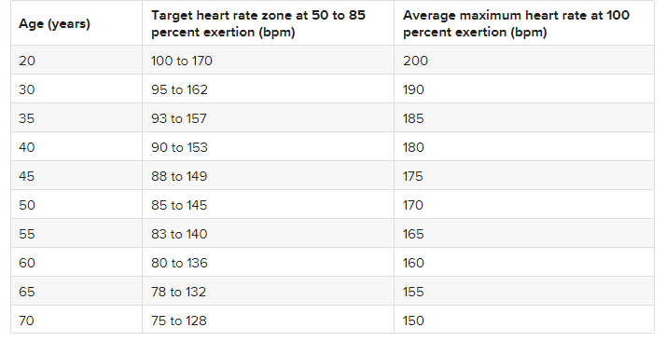 Temperature increases with + 1°F if you are experiencing anxiety or fear. It can be monitored for about five to ten minutes. The pulse rate, which is descried as the rate of contraction and expansion of the arteries per minute, can be measured with using the rates in the diagram below.

Figure 2. Pulse rate

Given that some might be intoxicated; the victims wouldn’t have a chance to defend themselves or even ask for help. There are certain traits that make one a rape-target, given that the women are highly likely to experience assault, women on their phone doing other activities while walking because they are off guard. There factors that favour the perpetrators, the use of a weapon to threaten the victim and the attack is most likely bound to happen very early in the morning or late in the night since there would be few people to witness.

## 2.3 Existing Solutions for Sexual Violence

The existing systems include;

### 2.3.1 ATHENA

It is a black silicone pendant, product of Olympus software, the size of a half-dollar and can be pinned to a purse, clothing, or even worn as a necklace. Depends on the user’s lifestyle. The device has a push (sunken) button at the centre to prevent accidental alerts, user holds it three seconds to prompt an alarm that will immediately inform/ notify the selected contacts of their live location, instead, if pressed three times in quick succession a silent alarm is sent, this is very useful when the users does not want to raise suspicion when she feels threated. ( 10 Best Tech Devices to Prevent Rape, 2017)

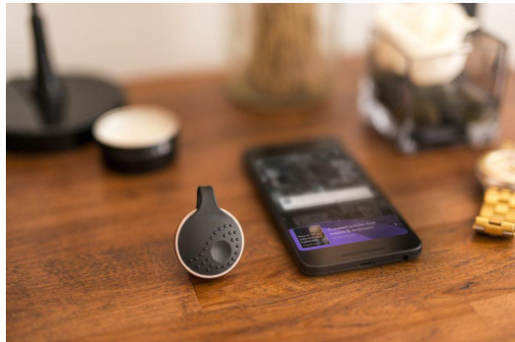Silent ROAR is mode sends a message without an alarm and Alarm Mode, which sounds an alarm to emergency contacts. Athena also has 911 calling capabilities and via the ROAR Personal Safety app, users also have access to self-defence videos, general safety awareness tips, and the latest news related to gender equality.

Figure 2. Athena

### 2.3.2 Watch Over Me

This is a mobile application that allows the user to set a timer when they are travelling alone. The user has the ability to shake the phone in case they are unable to call someone, It works even when the phone is locked, after activating the application, the video camera and alarm are triggered, and an alert is sent to the enlisted contacts. The application notifies the user when they are approaching a high-[crime](https://www.psychologytoday.com/us/basics/law-and-crime) region.

The user can add updates in the like pictures. If the timer ends and the victim has not pressed the I’m safe button, the enlisted contacts are sent to the last known location and any information uploaded. The app is activated based on dormancy;

However, this technique is only limited to the information provided by the application; in case your phone is thrown away that can be used to disguise your last known location or if somebody steals the mobile phone.

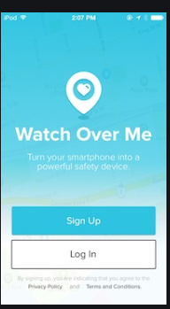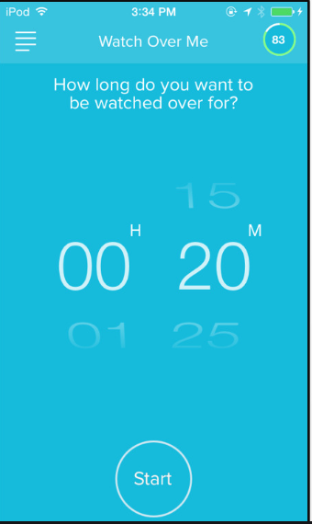

Figure 2. Watch Over Me

### 2.3.3 SMART GADGET FOR WOMEN SAFETY USING IoT

The system aims to help the victim with self-defence, it is a glove embedded with circuits that emit shock to the perpetrator which gives the victim time to rescue herself. The elective glove does not need a manual assistance to activate it. The device constitutes of a camera, motion sensor and GPS module. There is a motion software which activates the device if there is any suspected activity in front of the camera. This is how the system work, the camera captures the image of the perpetrator and the GPS location of the victim together with image are E-mailed from the device.

There is second aspect of this project which emphases on defence using pendant. When activated the pendant has a flash light which blinds the attacker’s vision and make an alert call to the victim’s family/police station requesting for help.

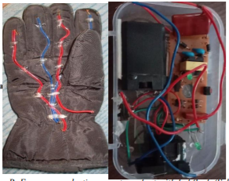

Figure 2. Smart Garget

### 2.3.4 Prevention Education

The education programs that have been that different adapted by different institutions to different types of age groups like teens and college students. The students’ normal curriculum won’t be interfered with, however, a lot of emphasis has been placed on prompting student participation rather than presenting an entirely instructive program this way the students get to grasp the idea on a deeper level. Programs for older students may include: Setting clear personal boundaries, developing healthy approaches toward emotional and sexual relationship and confronting sex role stereotypes.

The University of Michigan has a nationally known, full-fledged Sexual Assault Prevention and Awareness Centre that offers a wealth of services to the campus community. Their campus rape crisis centre provides peer education on rape prevention, organizes rape awareness weeks, and provides programs for men through the Men's Outreach Committee. (Joel Epstein & Langenbahn, 1994).

### 2.3.5 SHE‐ Society Harnessing Equipment (IoT)

It is an attire embedded with an IoT electronic device. The attire can distribute an electric shock to attackers strong enough to cause severe burns, protecting the victim from any of the electricity. The garment is fixed with four sensors to detect the position of your fingers; a joystick, an accelerometer and four push buttons. A pressure sensor is connected to an electric circuit that electrocutes the perpetrator when it is squeezed forcefully, and the system is placed in a two-layer fabric, which prevents the victim from electric shock. (ZIKRIYA, G, MATH, & TANKASALI, 2017)

The pressure measures or can differentiate actions like a grab or a pinch. The pressure applied on clasping cannot be quantified as a harmful action because it does not fulfil the conditions for activating the device. (Graham, 2013)

The sensors and buttons can put in way that is comfortable to the user. The user can manually activate the sensors in case she feels threatened and later linked to the mobile application or monitor.

## 2.4 Gaps in Existing Systems

### 2.4.1 Expensive to acquire and maintain

Athena is quite expensive for an average citizen even though it is not in Kenya, it goes for $129 which means only the rich ones have the protection. When it comes to security issues, the solutions created should at least encompass a huge number of the targeted population if not all.

### 2.4.2 Incompatibility

Athena and Watch Over me are mobile applications, this means all the users must have smart phone even though in Kenyan many people are able to acquire them, those with analogue phones are not able to get these services assuming that they were available in this region.

## 2.5 Conceptual Diagram

The conceptual diagram gives visual representation of how the proposed system is going to work.

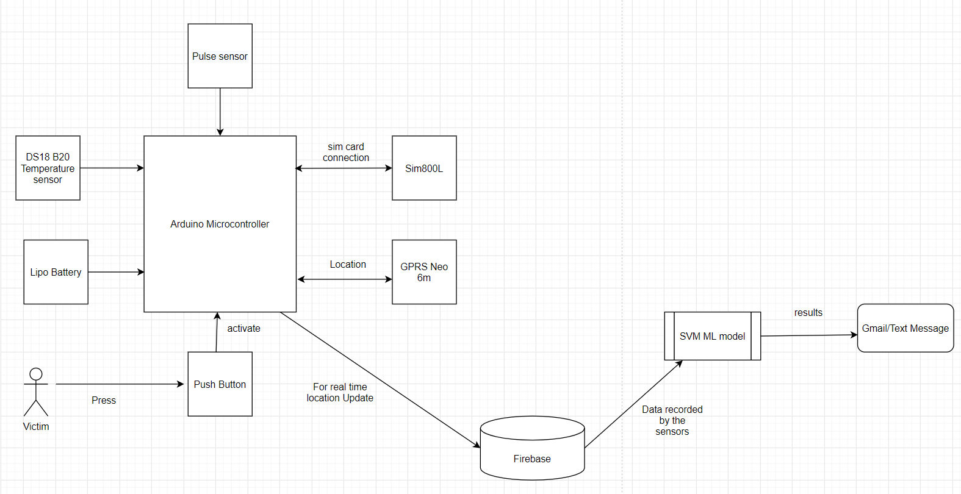

Figure 2. Conceptual diagram

# Chapter 3: Research Methodology

## 3.1 Introduction

This chapter discusses the system development methodology that best suites the proposed Iot system, system deliverables that explain how different modules of the system work and finally the techniques and tools used to build the system.

## 3.2 System Development Methodology

The proposed system will follow the Rapid Application Development methodology(RAD). This methodology contributes to increase in productivity and hence quicker development of the project. This approach enables the use of prototypes which reduces the complexities during development because it is easier to foresee production problems and logical construction of the entire project. This approach also enables the developer to break it into smaller tasks which are manageable hence aids in designing the entire system faster. Lastly, it brings about reduction of risk by continuously testing the prototype and faster production of the proposed device.

RAD has four stage as shown in the diagram below:

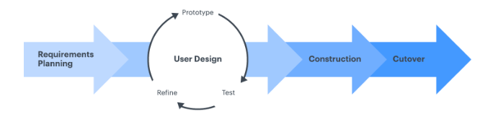

Figure 3. RAD

### 3.2.1 Requirement Phase

This phase looks into determining the requirements for the construction of the proposed system. This entails collection of data from women by use of questionnaires which helps them keep their identities anonymous. The aim of this process is to unearth:

1. Understand how victims are treated
2. Record enough data for future references given that there is no a coding system to register data on violence against women used systematically within and across agencies.
3. Know what victims go through during assault

The questionnaire sample picture is on the last page.

### 3.2.2 Design Phase

The design of the proposed system will be guided by the Unified Model Language diagrams which include Data Flow Diagrams, Use case diagrams, Context diagrams and sequence Diagrams. They are able to illustrate how the system works including all entities. These diagrams will be visually outlined in chapter four.

### 3.2.3 Construction Phase

Fritzing is the IDE going to be used to simulate the entire project. It enables dragging and dropping of preferred devices and later wring code using Arduino language that will make the entire system work. It is assumed that if it works well on the IDE, the hardware devices will connect work practically well. Setting up a firebase project that will enable the use of GPRS because of the communication aspect of the project (GPS and GSM).

For the practical construction, Arduino IDE is going to be used.

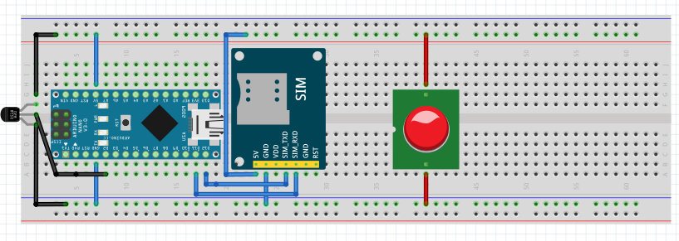

Figure 3. Simulation

### 3.2.4 Transition Phase

This stage entails testing the prototype for production purposes. First the devices will be individually connected and the codes wills be tested, later there will be a general code for the entire prototype to code.

However, there are types of tests done to the prototype.

**Usability Testing:**

The proposed device is a watch like device which is activated by pressing the push button. This is device that is easy to use.

**Compatibility Testing:**

Given that the system is sending messages with the location attached to it, all mobile phones regardless the operating system can receive the text, and can access the location using google maps since there is an offline mode in case one of the contacts is not able to access the internet.

**Performance Testing:**

This will be measured by how fast the message will be sent one the push button is pressed. The duration of time taken for communication will determine reliability of the system. If it takes a short time to send the text message together with the real time location that means the contacts might be able to respond quickly.

**Security testing:**

Data being sent is already encrypted. Firebase is the preferred database because of its high quality security features.

## 3.2 Project Deliverables

The proposed system has two modules:

### 3.2.1 Victim Module

The Victim’s module involves the user activating the entire IoT system by pressing the push button. The user is able to save the trusted contacts on the SIM card which then the text messages are sent to, together with the real time location.

### 3.2.2 Admin Module

The Admin module entails the monitoring the backend especially the database. Data going into and out of the database should be real time. The admin handle errors to enforce reliability of the system.

## 3.3 System Development Tools and Techniques

The tools and techniques used in for the development of the proposed system include:

#### 3.3.1 Fritzing

This is the IDE going to be used to simulate how the devices will be connected.

### 3.3.2 Arduino IDE

The IDE enable writing and uploading of code which will be used to make the devices work.

### 3.3.3 Firebase Database

All the data collected is recorded in this database for better services.

### 3.3.4 Fusion 360

This will be used to design the final product which is a watch-like device.

### 3.3. 5 Python

This is the language used to develop the machine learning model.

### 3.3.6 Devices

Given that a number of sensors will be used, Arduino fits best with the proposed system. The items included are; Arduino Nano/pro micro, Sim800L, Neo 6m, at Pushbutton, Lipo charger, Lipo battery, DS18B20, Jumper Wires, Pulse Sensor, 2 LEDs, Breadboard, Buzzer and Resistor.

#### 3.3.6.1 Arduino Nano 3.0

Figure 3. Arduino

This is a microcontroller that is connected to the rest of the devices for them to work. It is based on the ATGmega328p and it is simpler to use.

Power supply 5V

#### 3.3.6.2 Sim800L

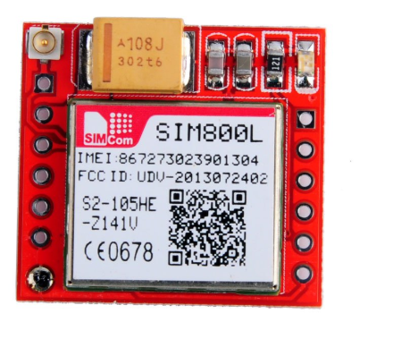

Figure 3. Sim800L

This is a GPSP modem that allows the users to send text messages, make calls and connect to the internet through GPRS.

Power supply – 3.4V - 4.4V

It supportsCS-1, CS-2, CS-3, and CS-4 GPRS coding schemes

It has a SIM card interface

## 

#### 3.3.6.3 Neo 6m

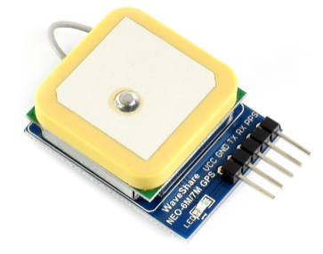

Figure 3. Neo 6m

It is a GPS receiver that can pinpoint locations anywhere in the world. It is programmed to know the exact positions of the satellites and calculates how far it is from each satellite by working out the time it took for the its signals to arrive.

#### 3.3.6.4 DS18B20 Temperature Sensor

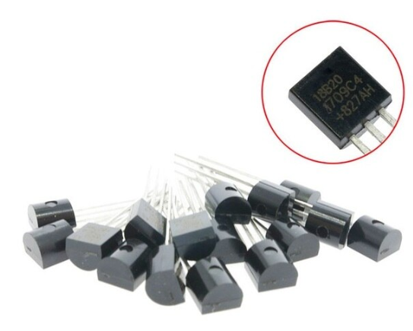It is used to measure the body temperature, works well in harsh conditions and measures a wide range of temperature from -55°C to +125° with a decent accuracy of ±5°C.

Figure 3. Temperature Sensor

#### 3.3.6.5 Pulse Sensor

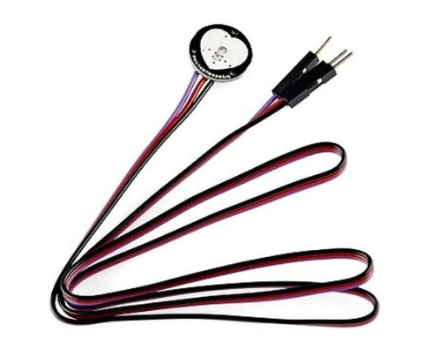

Figure 3. Pulse Sensor

It is a heart rate sensor that works in a way that when a finger is placed on it, the pulse sensor converts the heart beat into a digital signal which is indicated by the LED upon each heartbeat.

### 

# Chapter 4: System Analysis and Design

## 4.1 Introduction

System analysis can be defined as a method of scanning through into a particular system in order to determine its purpose or goals and to discover problems that may arise. System design is a process that illustrates the architectures of the interfaces, processes and activities of the proposed system. This chapter discusses the functional and non-functional requirements that the system achieves and illustrates the System design diagrams.

## 4.2 System Analysis

### 4.2.1 Functional Requirements

These describe a specific main functions of the system.

The system is able to send messages to a recipient. Once the button is pressed, using sim800l and Neo6m a message is sent attached with a live location of the sender.

The neo6m is

**Non–functional Requirements**

Theses describe the system’s features which make the enhance the usability of the system.

**Availability**

**Usability**

**Compatibility**

**Functionality**

**Reliability**

**Portability**

## 4.3 System Design

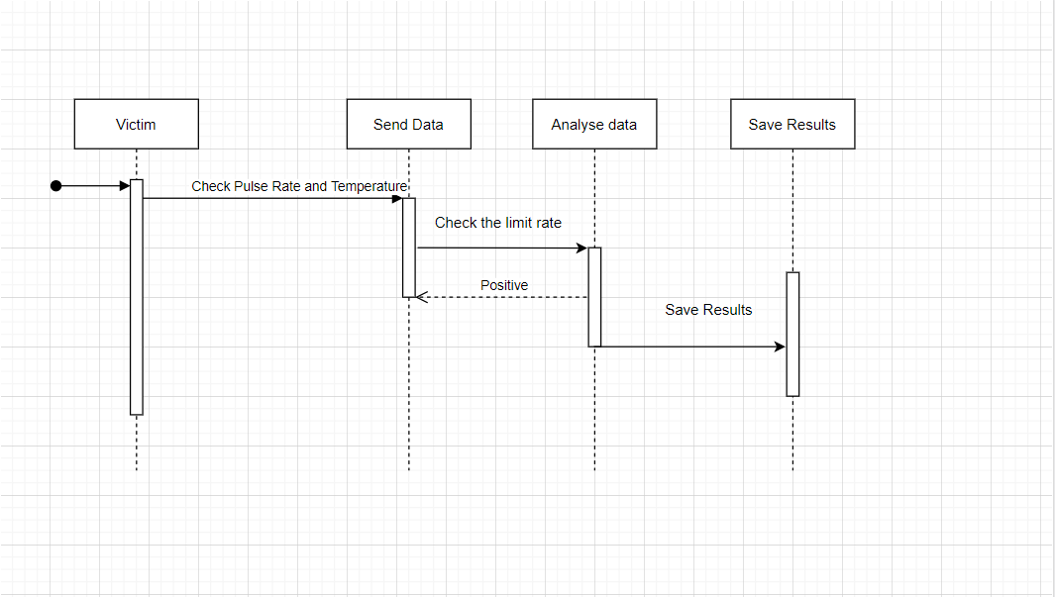

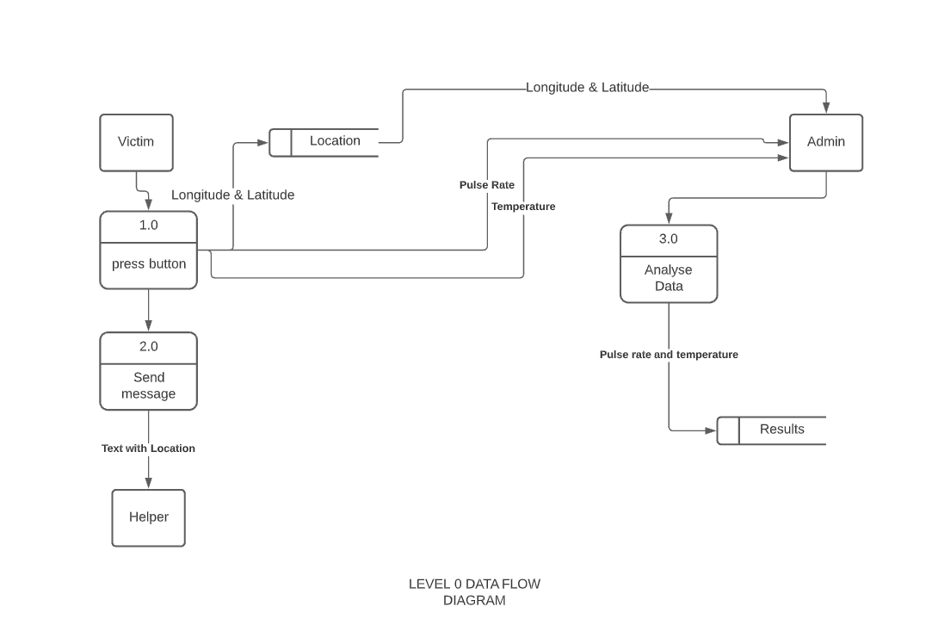

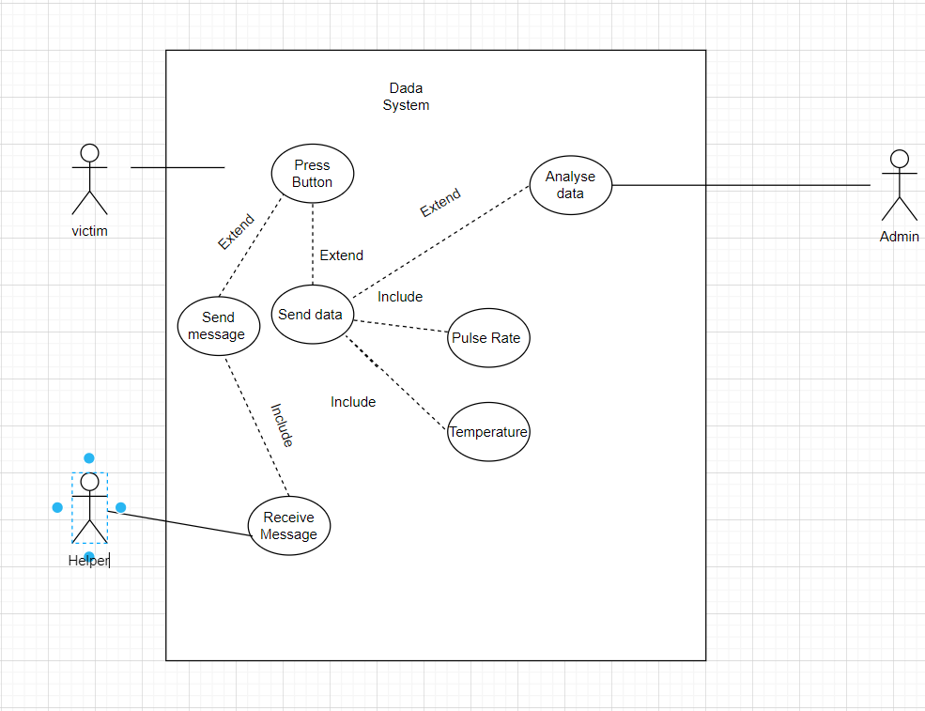

# Chapter 5: System Testing

## Introduction

## Test Environment

## Test Cases

## Test Results

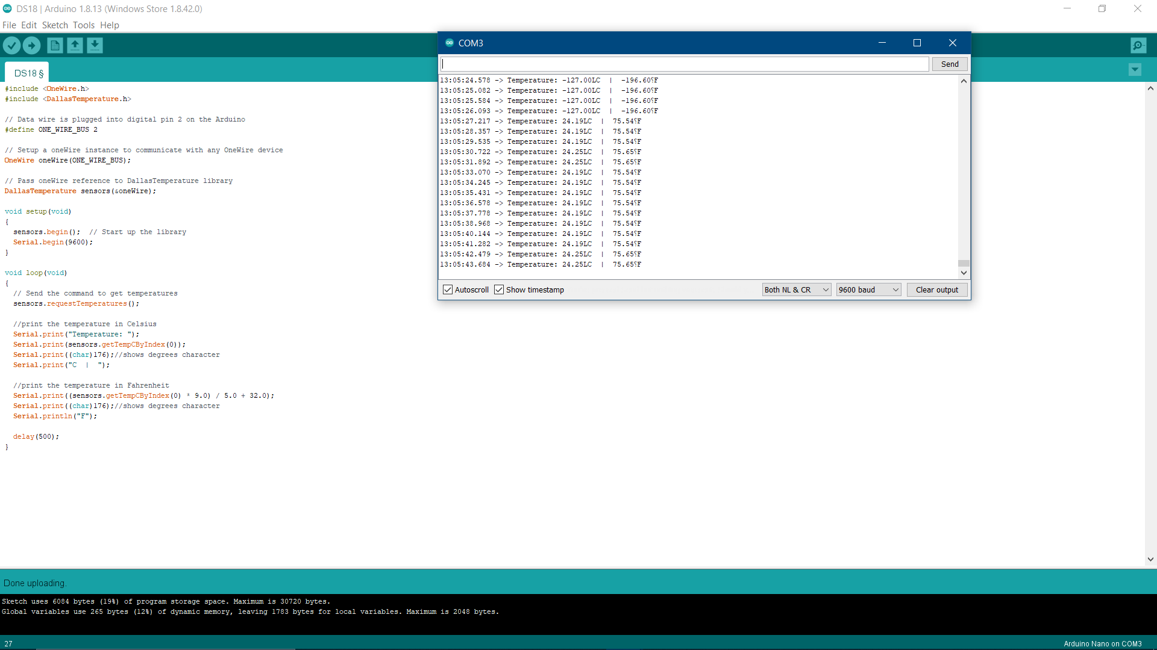

# Chapter 6: Conclusion and Recommendations for Future Work

## 6.1 Conclusion

Many a time the subject will be brought forward, there have been solutions as earlier discussed, but it is safe to state that these solutions are better considered as ineffective if we don’t put in mind that we need to take care of one another. Sexual violence affects all genders. It is time to stand against this grotesque mindset that it is a normal thing to happen, my project may be a technical solution towards it, but the real solution lies on the realization that; you are human and no human can be more human than you, in short, we are all equal. With that said, more data needs to be collected, these cases need to be taken more seriously and victims don’t need to feel ashamed, this is not only for us but for the future generations. Solutions don’t need to be fully efficient right away but the steps towards taking action are what really counts. A good example would be, for many years HIV has been a disease that has killed many it is up to recently more people are able to receive treatment luckily people can live long, bear in mind that these are prayers being answered from those suffered from it a long time ago.

## 6.2 Recommendations for Future Work

1. A mobile application can be built on to depict the practical aspect of this project and it is better if it utilises USSD functionality. This would have a diverse reach to people since not everyone can access internet.

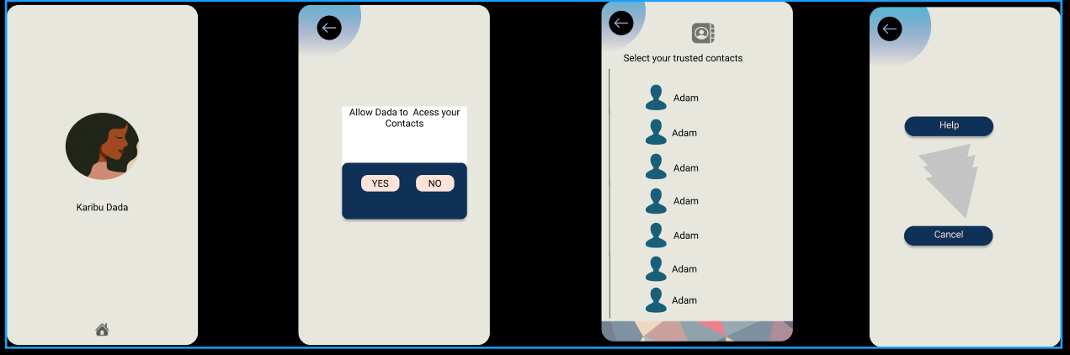

1. Storing more data on sexual violence in order to generate datasets.

## 

# References

(n.d.). Retrieved from World Population Review: https://worldpopulationreview.com/world-cities/nairobi-population/

*10 Best Tech Devices to Prevent Rape*. (2017, April 15). Retrieved from Phychology Today: https://www.psychologytoday.com/us/blog/the-body-blog/201704/10-best-tech-devices-prevent-rape

Minnesota Advocates for Human Rights. (2003). *What Is Gender-Based Violence?* Retrieved from Stop Violence against women: http://www.stopvaw.org

© National Sexual Violence Resource Cente. (2010). *The Impact of Sexual Violence.* Retrieved from www.nsvrc.org

(2019). Retrieved from Rape Prevention Education: https://rpe.co.nz/

ajdupree. (2014). *Instructables*. Retrieved June 2020, from https://www.instructables.com/id/Arduino-Stress-Detector/

Barr, C. (2019, September 19). *Thousands of rape reports inaccurately recorded by police*. Retrieved from The Guardian: https://www.theguardian.com/society/2019/sep/19/thousands-of-reports-inaccurately-recorded-by-police

Bigio, J., & Vogelstein, R. (2017). *Countering Sexual Violence in Conflict.* Council on Foreign Relations.

Bramley, E. V. (2015). *The Guardian*. Retrieved June 14, 2020, from https://www.theguardian.com/cities/2015/aug/13/can-the-safecity-app-make-delhi-safer-for-women#:~:text=The%20Safecity%20app%20lets%20women,happened%20and%20when%20it%20happened%E2%80%9D.

Centre, N. C. (2014). *GENDER BASED VIOLENCE IN KENYA.* Nairobi.

counselling center. (n.d.). *LOYOLA University Maryland*. Retrieved June 21, 2020, from https://www.loyola.edu/department/counseling-center/students/concerns/sexual-assault/reactions

*Daily Nation*. (2019, December Monday). Retrieved from https://www.nation.co.ke/news/Kilifi-leads-in-Kenya-incidence-of-rape/1056-5369726-28pfhfz/index.html

Graham, F. (2013). *BBC*. Retrieved June 14, 2020, from https://www.bbc.com/news/business-22110443

Joel Epstein, E., & Langenbahn, S. (1994). *The Criminal Justice and Community Response to Rape .* National Institute of Justice. .

Jordan, C. E., Campbell, R., & Follingstad, D. (2010, july). Violence and Women’s Mental Health: The Impact of Physical, Sexual, and Psychological Aggression. pp. 607–628.

Justice and Gender-Based Violence. (2013). In *Revue Internationale de Philosophie, Vol. 67, No. 265 (3), PHILOSOPHY AND VIOLENCE* (pp. 259-275). Revue Internationale de Philosophie.

LunesCuatro. (2019). *Instructables*. Retrieved June 2020, from https://www.instructables.com/id/Blood-Pressure-Monitor/

Manzatto, A. A. (2019). *Medium*. Retrieved June 19, 2020, from https://medium.com/omdena/is-this-place-safe-274fc31c02c6

mybotics. (2018). *Instructables circuits*. Retrieved june 2020, from https://www.instructables.com/id/Pulse-Sensor-With-Arduino-Tutorial/

Parker, R. N., & Auerhahn, K. (1998). *ALCOHOL, DRUGS, AND VIOLENCE.* California.

Review, A. (2014, July 18). Sexual Violence and Its Discontents. pp. 139–154.

*TECHFASTER*. (2016). Retrieved from http://techfaster.com/stiletto-safety-device/

*Wangu Kanja Foundation*. (2016). Retrieved from https://wangukanjafoundation.org/

ZIKRIYA, M., G, P. M., MATH, S. R., & TANKASALI, S. (2017). *SMART GADGET FOR WOMEN SAFETY USING IoT.* BAGALKOT: BASAVESHWARA ENGINEERING COLLEGE.

# Appendix

Gantt chart

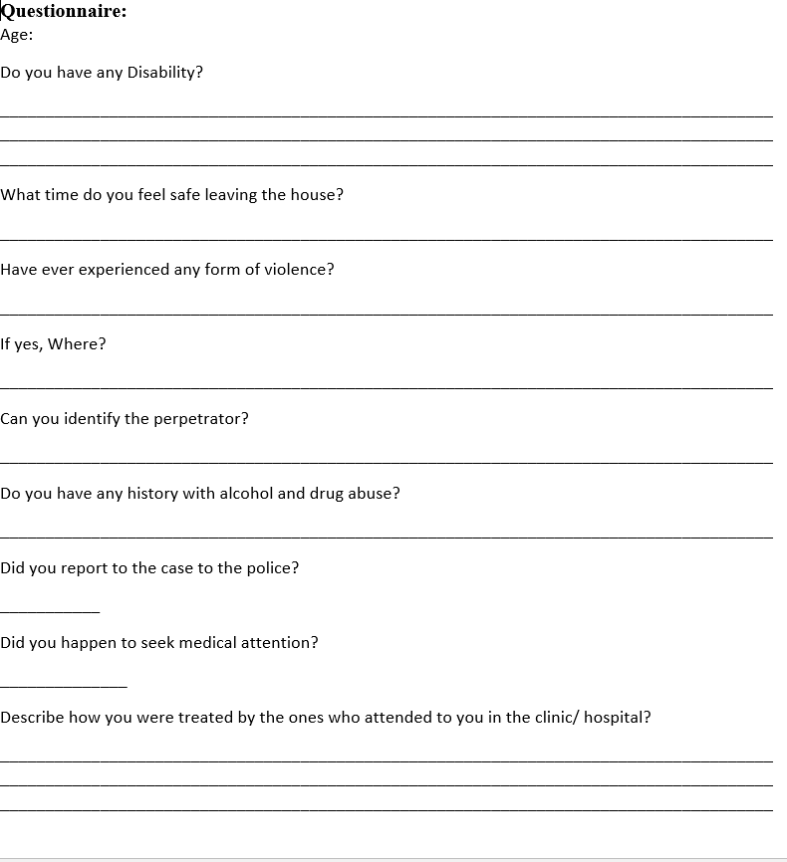 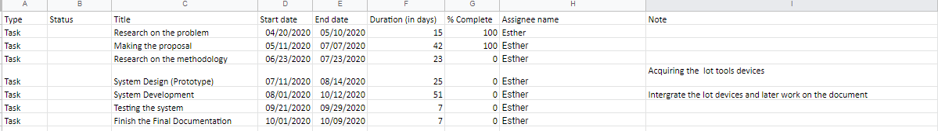

Questionnaire

Gantt Table